River Heights School – Our Day at Neubauer Farms

Our agenda…
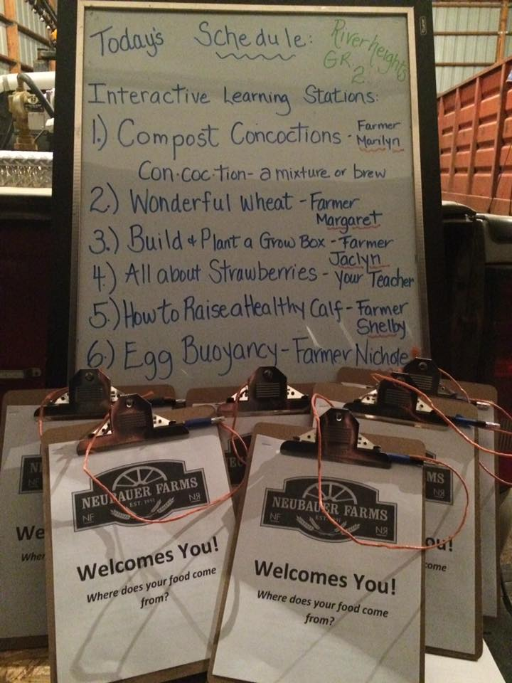

We formed hypotheses and tested these during our ‘Egg Buoyancy’ experiments and learned the connection between an egg’s freshness and it’s level of buoyancy.
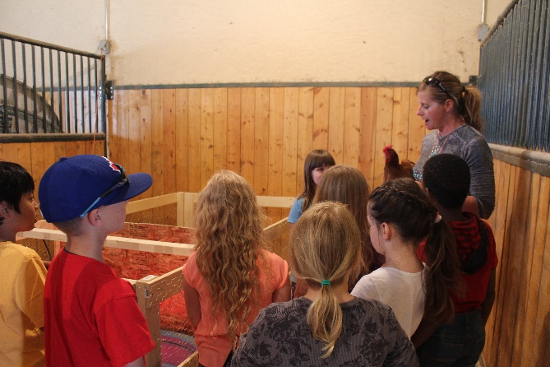
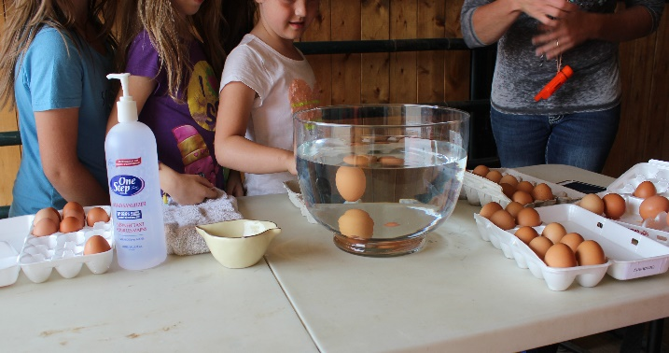

We learned about composting and had the opportunity to observe worms in action. Later, we had the opportunity to build and plant our own grow boxes, which were were able to take with us to grow our own salad.
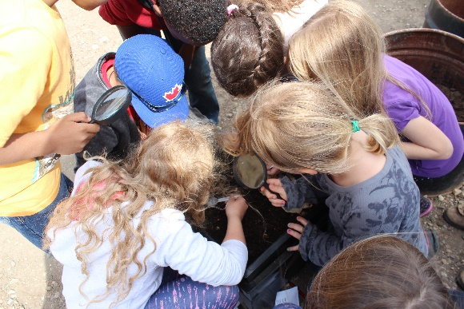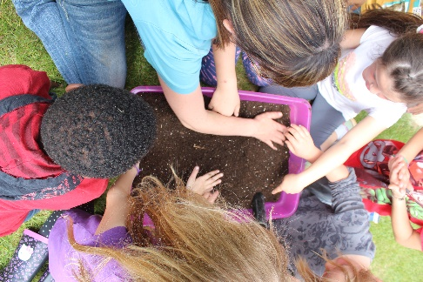
We learned about wheat, making dough and had the opportunity to explore, play and use our imaginations.
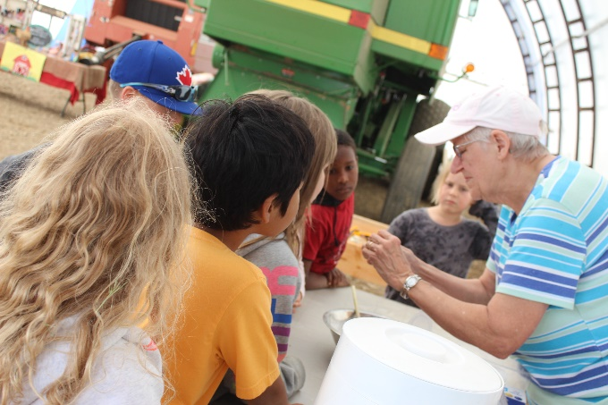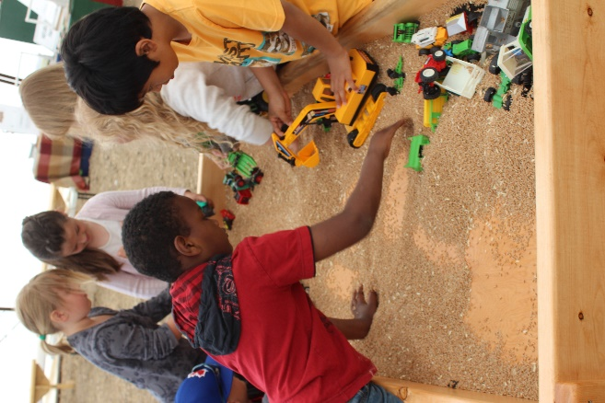

We had the opportunity to meet baby chicks…
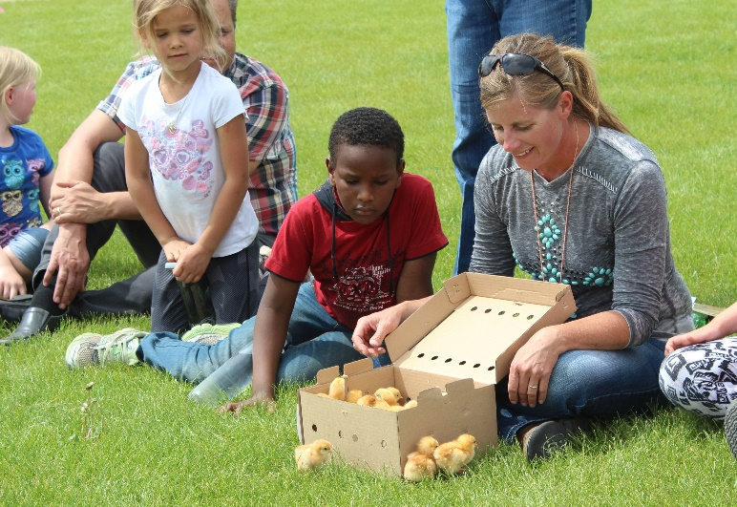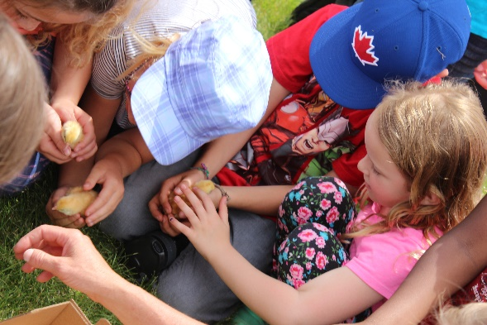

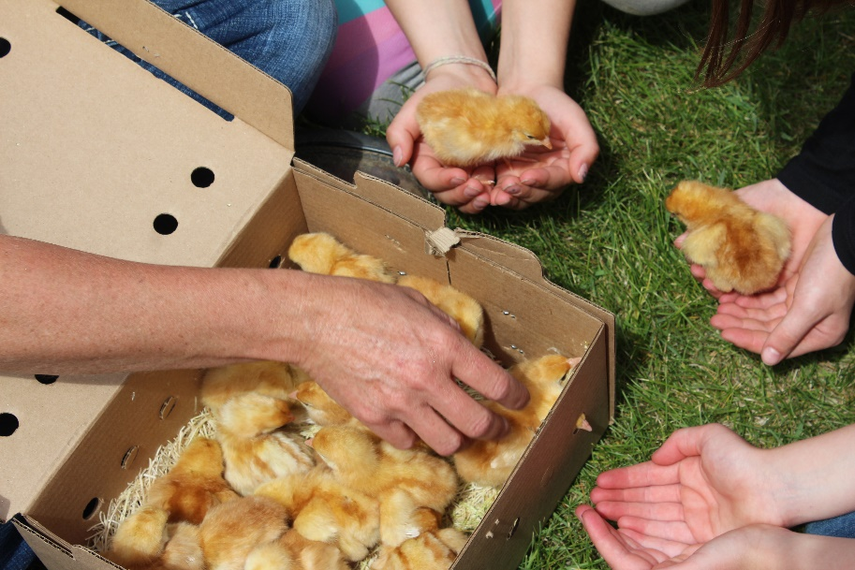
I would like to take a moment to say a few words about our day at Neubauer Farms. Three grade two classes attended and despite the large size of our group, each student had the opportunity to participate fully in meaningful learning throughout our day.
Neubauer Farms provided engaging, hands-on learning with clear connections to the Alberta Program of Studies. Before our arrival, Nichole invited us to visit the farm, to discuss relevant curricular concepts and choose suitable activities for our Grade Two classes. We were beyond impressed with the preparation and organization of the activities provided for our students, the attentiveness of the staff to student curiosity and the relevance of each aspect of our day. The students enjoyed the experience and could clearly articulate their learning as we reflected on our farm experience. Many students had never been to a farm before and were asking if we could visit Neubauer Farms again before we had even returned to the school.

Overall, our time at Neubauer Farms was worthwhile, engaging, informative and fun. I appreciated the genuineness of the staff and their ability to share the important role of agriculture in our community and provide students with a clear understanding of where our food comes from.

I see value in the Neubauer Farms experience for children of all ages and highly recommend their educational program.

Sincerely,
Dawn Hunt
Dawn Hunt
Grade Two Teacher, River Heights School

