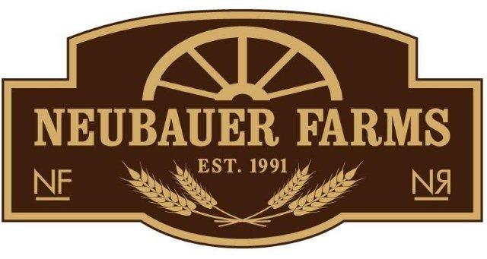
P.O. Box 1348, Medicine Hat, AB T1A 7N2
403.580.9654
Community Supported Agriculture

Dear Potential Subscribers to the Neubauer Farms CSA Program,

We hope this letter finds you well, and if you are like us, you may already be counting down the days ‘til spring arrives! For now, we wait, and we plan for the upcoming planting season.
2017 will mark the start of our 5th year of our CSA program here in sunny Southeast Alberta. Our CSA program has been an endeavor that we have enjoyed immensely! Growing food just for you is very meaningful to us.
In our constant effort to improve our program, and to give our customers more of what they really want, we are very excited to make some announcements about a few changes for this upcoming growing season.
We have identified the following two areas for growth and development: 1) vegetable quantity and variety and 2) “on-farm pickup” as the only option to receive farm-fresh produce.
In light of this, Neubauer Farms will be partnering with another local grower (I fully endorse the growing practices used by this operator) and this will allow for the following improvements:
- More of a “guarantee” of produce volume
- Consistent availability of produce. By accessing produce from another local grower, I will be in a position to better mitigate risks and crop failures
- There will be more produce variety such as broccoli, cabbage, celery and earlier tomatoes, you may also have the option to pre-order pickling cucumbers, as well as extra beets and tomatoes for canning
In addition to this, Neubauer Farms will be providing “Farm-Fresh to your Door” (available in Medicine Hat only). This will be a delivery model that will eliminate your weekly commitment to drive out to the farm. Instead, representatives of Neubauer Farms will drop your produce off at your door, mid-late afternoon on a set delivery day each week. If you are not home, you may leave a cooler with ice packs on your front step and we will leave your bounty at your home, just waiting for you to enjoy.
Here at Neubauer Farms, we love our hens and because of this, we will continue to offer you farm-fresh eggs from free-run hens. Our hens have access to a spacious indoor barn and the safety of an enclosed outdoor run. We do wish that they could be truly free-range, but we attempted to do this last fall and had an immediate coyote problem right in our yard.
We anticipate that our vegetables will be available starting the week of June 27 until the week of September 12. We will then have one last “Thanksgiving Harvest” delivery the week of October 3. This generates a total of 13 weeks of produce availability.

As many of you may be aware, Neubauer Farms is the founder and operator of the Growing Minds Agriculture Education program. We teach kids all about “Where their food comes from” by transforming our farm into a classroom. Last year we hosted over 3,300 students. Our program runs in May and June, and from Mid-September until October. Planning and programming for 3,300 eager learners becomes a full-time vocation for me during these busy times. This coupled with the fact that I employ summer students to help run the CSA program are the two reasons why the CSA ends by mid-September.
We hope that these modifications to our CSA model will enhance your local food experience with Neubauer Farms. Included below is a produce production guide. Please keep in mind, sometimes Mother Nature doesn’t read the guide, but with three years of CSA growing experience, I am quite confident that you can expect this produce within the guidelines indicated.
As always, if you have any questions, I may be reached by email at nneubauer@xplornet.com or via phone 403-580-9654. I am now accepting enrollment from new subscribers. Please fill out the enrollment form and either email it back to me to confirm your registration, or print it off and include it with your payment. Your notice to enroll is required by February 15, 2017 to secure your spot. You may pay via cheque or internet transfer. Your first cheque required to secure your share is to be issued for February 29, 2017 with the balance payable by May 1, 2017. Please let me know if you would prefer to make other payment arrangements.
I look forward to the opportunity to grow your food. I am a proud farmer, we produce grains, pulses, forage, oilseeds and raise beef cattle, I know that the food we grow does feed “people”, in the most generic sense. However, the past 4 years that I have spent growing food for families throughout our community has been a very fulfilling, gratifying experience because of the personal connection that we share.

Yours truly,

Farmer Nichole
Neubauer Farms

Week of (estimate of produce availability)
June 26 | rhubarb, spinach, green onion, swiss chard, beet tops, eggs, mixed greens
July 3 | swiss chard, beet tops, spinach, green onions, lettuce, eggs
July 10 | Baby beets, spinach, peas, green onions, sugar peas, lettuce, kale eggs
July 17 | Baby beets, baby potatoes, lettuce, swiss chard, green onions, peas, eggs
July 24 | Cucumbers, zucchini, baby potatoes, beans, swiss chard, head lettuce, eggs
July 31 | Cucumbers, zucchini, baby potatoes, tomatoes, beans, lettuce, beets, eggs
Aug 7 | Baby potatoes, baby carrots, beans, zucchini, cucumber, onions, beets, eggs
Aug 14 | Cucumbers, carrots, zucchini, broccoli, onions, baby potatoes, cucumbers, eggs
Aug 21 | Cucumbers, beans, potatoes, onions, kohlrabi, turnip, zucchini, corn, eggs
Aug 28 | Corn, potatoes, onions, kohlrabi, zucchini, carrots, beets, eggs
Sept 4 | Corn, potatoes, carrots, tomatoes, peppers, cucumbers, eggs, eggplant
Sept 11 | Corn, potatoes, onions, cabbage, carrots, garlic, fall squash, tomatoes, turnip, eggs, spaghetti squash
Oct 2 | Potatoes, carrots, onions, pumpkin, spaghetti squash, butternut squash, beets, eggs

