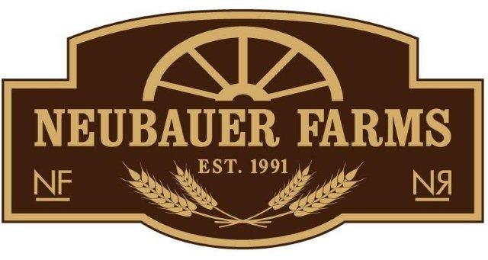
P.O. Box 1348, Medicine Hat, AB T1A 7N2
403.580.9654
2016 Community Supported Agriculture Enrollment Form
Full Name:
 | Last | First
Address:
 | Street Address |  | Apartment/Unit #
 | City | Province | Postal Code
Home Phone: |  | Mobile Phone:

Email Address:

Payment Plan: A deposit of 50% is due by February 29, 2017, the balance is payable by May 1, 2017. We accept Cash, Cheque and e-transfer. Please make cheque out to: Nichole Neubauer
Mail THIS form along with payment to: Box 1348, Medicine Hat, AB T1A 7N2 Thank you! If you are paying via e-transfer, this is a fillable form, please fill it out from your computer and email it back to me at nneubauer@xplornet.com note: we need to have this form returned in order to compete your enrollment.
Check your Choice (double click the shaded box and click “checked” and “ok” | Pricing
Full Share – Weekly on-farm pick-up | $525.00
Full Share – Farm-Fresh to your Door (weekly delivery) | $625.00

If you have selected on-farm pick-up please indicate which day of the week you would like to pick up your produce:
Monday Tuesday Wednesday Thursday
If you have selected to have your produce delivered farm-fresh to your door, we will be providing delivery to Medicine Hat on Wednesday afternoons.

Any additional comments:

