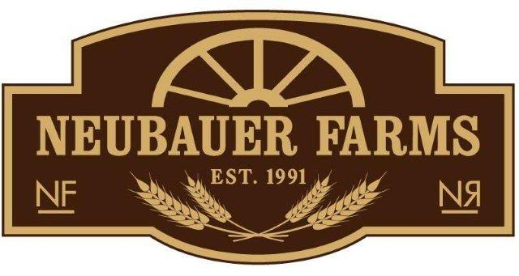

2015 Community Supported Agriculture Enrollment Form

Member Information
Full Name:
 | Last | First
Address:
 | Street Address |  | Apartment/Unit #
 | City | Province | Postal Code
Home Phone: |  | Mobile Phone:

Email Address:

Payment Plan: 2015 CSA Share Price: $500.00 ~ A deposit of $250.00 required by March 1, 2015 and the remaining $250.00 is to be paid in full by May 1, 2015. (We accept Cash, Cheque or On-Line payment transfer) – Please make cheque out to: Nichole Neubauer
Mail your completed form along with payment to: Box 1348, Medicine Hat, AB T1A 7N2 Thank you!

Are you interested in having free-range eggs added to your CSA share? (there is no additional cost)
☐ | Yes | ☐ | No

Please indicate the day of the week that works best for produce pick-up
☐ | Monday | ☐ | Tuesday
☐ | Wednesday | ☐ | Thursday | ☐ Friday

How did you hear about our CSA program?
☐ | Member from previous year | ☐ | Poster | ☐ | Newspaper publication
☐ | Friend / Family member | ☐ | Facebook | ☐ | Website
☐ | Other

